**DAILY ONLINE ACTIVITIES SUMMARY**

|  |  |  |  |  |  |  |  |  |
| --- | --- | --- | --- | --- | --- | --- | --- | --- |
| **Date:** | **30/06/2020** | | | | | **Name:** | **NIKHIL KUMAR** | |
| **Sem & Sec** | **4thSEM. & ‘B’ SEC.** | | | | | **USN:** | **4AL19CS400** | |
| **Online Test Summary** | | | | | | | | |
| **Subject** | | **NULL** | | | | | | |
| **Max. Marks** | | **30** | | **Score** | | |  | |
| **Certification Course Summary** | | | | | | | | |
| **Course** | **SQL and Relational Databases 101** | | | | | | | |
| **Certificate Provider** | | | **Cognitive class** | | **Duration** | | | **5hr** |
| **Coding Challenges** | | | | | | | | |
| **Problem Statement1 :**  Write a C++ Program to Move all zeroes to end of array using Two-Pointers.  Given an array of random numbers, Push all the zero’s of the given array to the end of the array. For example, if the given arrays is {1, 0, 2, 6, 0, 4}, it should be changed to {1, 2, 6, 4, 0, 0}. The order of all other elements should be the same.  Examples:  Input: arr[]={8, 9, 0, 1, 2, 0, 3} Output: arr[]={8, 9, 1, 2, 3, 0, 0} Explanation: Swap {0 ,1} -> Resulting array {8, 9, 1, 0, 2, 0, 3} Swap {0 ,2} -> Resulting array {8, 9, 1, 2, 0, 0, 3} Swap {0 ,3} -> Final array {8, 9, 1, 2, 3, 0, 0}  Input: arr[]={4, 5, 0, 0, 0, 0, 6, 7} Output: arr[]={4, 5, 6, 7, 0, 0, 0, 0}  **Problem Statement2 :** Write a C Program to check whether the number is Ugly or not. | | | | | | | | |
| **Status: Executed** | | | | | | | | |
| **Uploaded the report in Github** | | | | | **Yes** | | | |
| **If yes Repository name** | | | | | 1.<https://github.com/Nikhil401/c-codding/blob/master/Move_Zero.cpp>  2. <https://github.com/Nikhil401/C-Coding/blob/master/UglyorNot.c> | | | |
| **Uploaded the report in slack** | | | | | **Yes** | | | |

**Online Test Summary : NULL**

**Certification Course Summary: Today I have completed the certification course “SQL and Relational Databases 101”**

**Snapshot is given below** 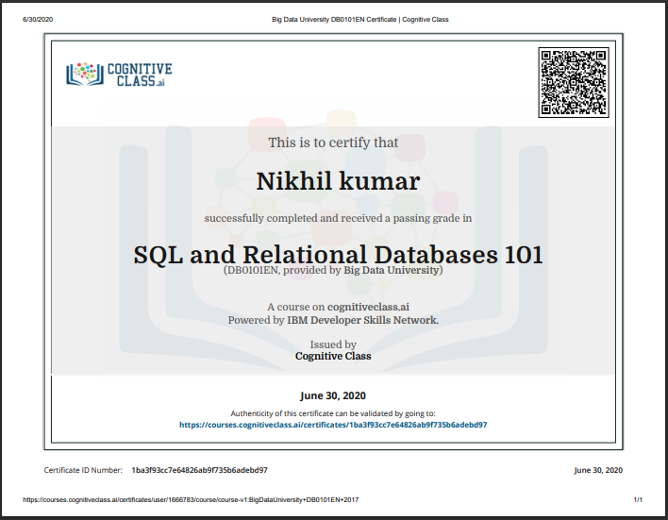

**Online Training : Today I had attended the online training organized by CSE Department AIET. The training was “input and output in c++, syntax and structure of c++ program” done by prof. Shruthi J shetty CSE Dept. After the session the quiz was conducted.**

**And the snapshot is given below**

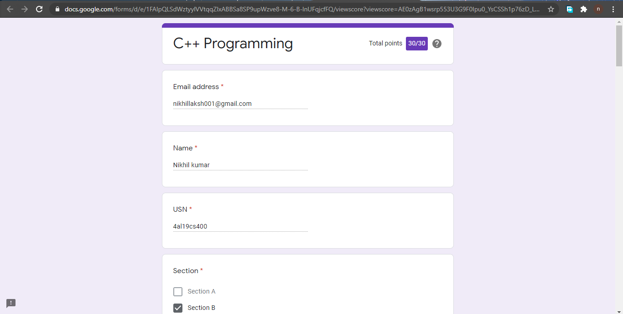

**Online coding summary: Today I had received programs which is mentioned in table above and I have uploaded into the github repository. Snapshot of the program is given below:** 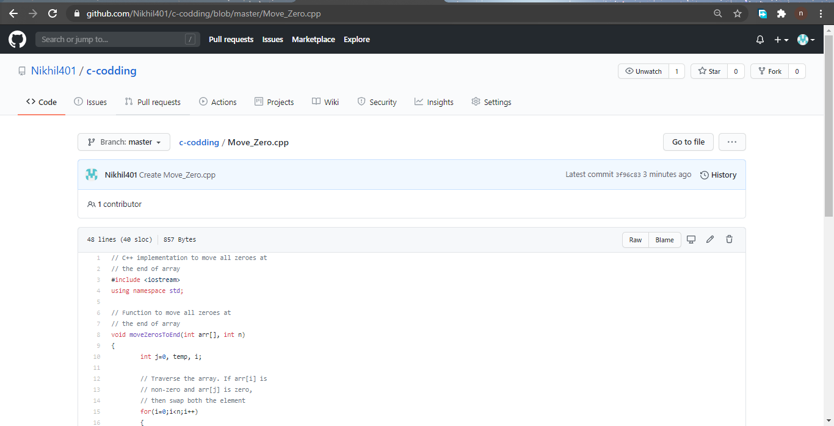

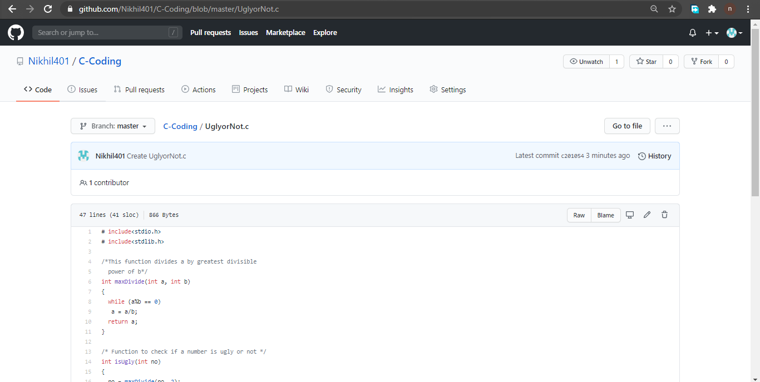 **Thank you.**